Name__________________ Period______ Date___________________
Way Down East (1920) directed by D.W. Griffith
Cast
Lillian Gish as Anna Moore
Richard Barthelmess as David Bartlett
Lowell Sherman as Lennox Sanderson
Burr McIntocsh as Squire Bartlett
Kate Bruce as Mother Bartlett
Mary Hay as Kate, the Squire’s niece
Creighton Hale as the Professor
Emily Fitzroy as Maria Poole, landlady
Porter Strong as Seth Holcomb
George Neville as the Constable
Edgar Nelson as Hi Holler

Credits
Directed by D.W. Griffith
Produced by D.W. Griffith
Written by Joseph R. Grismer
Anthony Paul Kelly
Cinematography by Billy Bitzer
Henrik Sartov
Distributed by United Artists
Release Date September 3, 1920
Budget $700,000
Box Office $2 Million

Way Down East (1920) is D. W. Griffith's classic, silent melodramatic film. He bought the film rights to the story, originally a stage play of the same name by an inexperienced writer named Lottie Blair Parker. First performed in the late 1800s, it soon became one of the most popular plays in the US. It barnstormed successfully across the US for ten years, but was considered outdated by the time of its cinematic production in 1920. Although it was Griffith's most expensive film to date (costing him $175,000, more than the entire cost of his 1915 classic The Birth of a Nation (1915)), it was one of his most commercially successful films.
The film is subtitled: "A Simple Story of Plain People," with director Griffith intending that its sweeping, lyrical, but epic style would convey an image of a vanished, unspoiled, pastoral America. It is a simple, timeless allegory of plain, everyday people in a story which attacks prejudice and bigotry. Lillian Gish's performance as Anna Moore is superb and flawless, beautifully photographed as having an inner light and spirituality. Moving, authentic and intense, she expresses the full range of emotions from a young, fragile and innocent country girl in the big city, to an ecstatically-infatuated new bride, to a betrayed "wife," to a bereaved unwed mother, and then into a matured woman
Way Down East (Web Exclusive)
by James L. Neibaur
Produced and directed by D.W. Griffith; cinematography by G. W. “Billy” Bitzer; edited by James Smith and Rose Smith; music by the Mont Alto Motion Picture Orchestra; starring Lillian Gish, Richard Barthelmess, Lowell Sherman, and Burr McIntosh. Blu-ray, B&W, 1:37 flat full frame, 149 min., 1920, mastered in HD from the Museum of Modern Art’s 35mm restoration, with original color tints; extras include gallery of images from the original souvenir program book, notes and excerpts from the play by Lottie Blair Parker, photos of William Brady’s 1903 stage production, and the ice floe sequence from the Edison Studio’s Uncle Tom’s Cabin (1903).
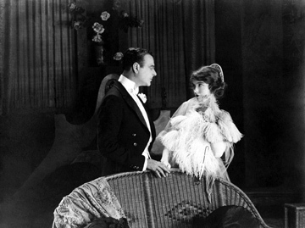
Lillian Gish as Anna with Sanderson (Lowell Sherman), the rich playboy who pretends to wed her
Despite a name that immediately stirs up controversy, D.W. Griffith’s importance to the growth of cinema is immense. Kino on Video continues to celebrate the filmmaker’s legacy with the release of Way Down East on Blu-ray, using beautiful 35mm preprint material.
By the time he filmed Way Down East in 1920, D.W. Griffith had defined silent-screen melodrama. First experimenting with the short films he produced at Biograph studios at the turn of the twentieth century, and later establishing himself with the majestic epics The Birth of a Nation (1915) and Intolerance (1916), Griffith would go on to explore themes of forbidden love with features like Broken Blossoms (1919) and True Heart Susie (1919). Broad gestures, grimacing close-ups, and fluttering eyes are all standard ingredients for each performance, and they are further emphasized by Griffith’s penchant for excessively long takes.
By the time the talking picture revolution eclipsed silent movies (less than ten years after the release of Way Down East), this style of performance was the subject of satire. Clips from silent dramas would be coupled with music and comical narration, relegating Griffith’s work to derisive parody.
What is interesting about Way Down East is that it is pretty much devoid of Griffith’s characteristic excesses, despite the fact that the film is based on a heavily melodramatic stage play by Lottie Blair Parker. Lillian Gish, the film’s star, recalled in her autobiography The Movies, Mr. Griffith, and Me: "we all thought privately that Mr. Griffith had lost his mind. Way Down East was a horse-and-buggy melodrama, familiar on the rural circuit for more than twenty years. As I read the play, I could hardly keep from laughing"
Despite the source material, Griffith eschews moralizing, and revamps the play into a film that critic Robert E. Welsh of Motion Picture News referred to as the filmmaker’s “‘first real, all wool, surefire audience picture”‘ featuring none of the “‘ragged edges of spirtualism”‘ or “‘beautiful scenic nothings”‘ that permeate much of his other work.
Lowell Sherman is alternately cunning and foppish as a rich playboy, while Gish is at her most naive and wide-eyed as the innocent country girl whom he dupes into having sex via a phony marriage, and whom he discards once she’s pregnant. Richard Barthelmess, who had played the Asian character lead in Broken Blossoms, is the hunky farmer whom Gish meets and falls in love with while concealing her sordid past, including having borne an out-of-wedlock child who died at birth. The complication arises when the playboy purchases a farm next to the one occupied by the Barthelmess character.
Way Down East is best known for the exciting climax featuring Gish trapped in the ice during a snowstorm. Shot on location during an actual blizzard, this harrowing sequence features Gish’s character, having fainted on an ice floe, floating toward a waterfall with her right hand and her hair in the freezing river. With no computer-generated effects, and no stunt woman taking Gish’s place, the actress recalls, in her autobiography, actually going out into this dangerous situation in subfreezing temperatures, "this kind of dedication probably seems foolish today, but it wasn’t unusual then. Those of us who worked with Mr. Griffith were completely committed to the picture we were making. No sacrifice was too great to get the film right...."
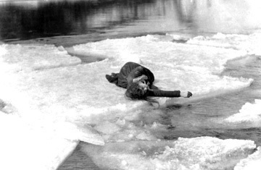
Gish on ice
Lillian Gish, who lived to the age of ninety-nine, recalled in later interviews that she never quite got full feeling back in the hand she let soak in the icy waters during this scene.
Way Down East shows the most positive aspects of Griffith’s filmmaking prowess. Working from a narrative steeped in nineteenth-century melodrama, Griffith makes the story absorbing and accessible to the modern viewer. While some of the comic relief featuring stereotypical bucolic characters might appear dated, the basic premise and its method of presentation do not.
The seduction scene, for instance, could have easily been overplayed, but Griffith draws the viewer in with a careful series of medium and close shots, allowing us to observe the body language of each character as well as their facial expressions. Ever since his early Biograph shorts, when Griffith discovered the close-up as a method in which to show a character’s thought processes, the broad stage-trained gestures of actors could be tempered to fit a more intimate presentation. Silent cinema relied heavily on conveying ideas with the mere lift of an eyebrow. Griffith’s choice of shots during the seduction scene clearly reveals the playboy’s cunning phoniness, and the innocent girl’s naive victimization.
Griffith’s filming of the breathtaking climax is even more triumphant. Switching from long shots, to medium shots, to close-ups with rhythmic precision, Griffith draws even greater suspense from the already palpable danger and heightens the dramatic tension. The structure of Griffith’s shots, and Billy Bitzer’s masterful camerawork are most impressive when shooting from further away, allowing for more of the snowy atmosphere to fill the screen, while Gish’s diminutive body lies to the left and towards the back of the frame. Seconds later, Griffith will cut to a much closer shot of the woman lying still on the ice, her hair hanging in the water, floating toward the edge. A few more seconds and Griffith switches to a medium shot, close enough to see the heroine clearly, but far enough away to absorb the extent of her danger. Added tension is offered by the Barthelmess character running across the blocks of ice floating in the river in an attempt to rescue her. Griffith will sometimes get as close as Gish’s full face in the frame, he will zoom from a medium shot to a closer one, adding further movement to the steady stream of the ice floe. Occasional shots of a furious waterfall show us the woman’s impending doom. Reports from period theater owners indicated that audience members would yell and scream throughout this sequence. Over ninety years later, this impact remains.
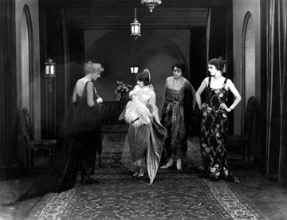
Anna preparing for her fake marriage
One of the special features on the Kino Blu-ray is a snippet from Thomas Edison’s early screen production, Uncle Tom’s Cabin (1903), on which the ice floe scene is based; the earlier film used an animated background quite effectively, given that it was made at the dawn of narrative cinema.
Way Down East was an enormously success, made for $175,000 (more than it cost to make the epic Birth of a Nation five years earlier), and grossing over $4.5 million, making it the fourth biggest moneymaking silent movie in film history. Unfortunately, it was also Griffith’s last great success. Despite his success with Orphans of the Storm the following year, Griffith’s films started to seem old-fashioned as the 1920s progressed. He had created cinema’s syntax, but his innovations became so basic and commonplace, so much a part of standard filmmaking, the fact that they were once new discoveries had faded from memory. The financial success of Way Down East was enough to keep Griffith active into the dawn of the talking picture era, but his initial plan to help form United Artists with Charlie Chaplin, Douglas Fairbanks, and Mary Pickford was thwarted by the failure of his movie, Isn’t Life Wonderful (1924).
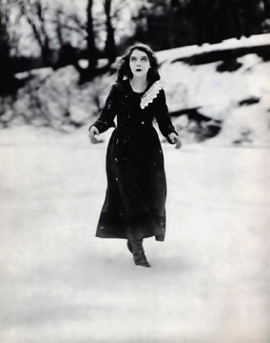
The new Kino Blu-ray offers the best available restoration
As with many silent movies that have slipped into the public domain, Way Down East has been available from various budget companies since the days of VHS video, often in grainy prints with music that did not match the action. Kino’s sharp, clear preprint material from the Museum of Modern Art’s 35mm restoration, including the original color tinting, allows for the sort of thorough appreciation that Way Down East warrants. Music by the Mont Alto Motion Picture Orchestra uses material from the original score played by theater musicians at the time of the film’s initial release.
The September 18, 1920 issue of Motion Picture News stated, "Griffith has scored with Way Down East because in every scene and every title he has made the most of each last drop of the human element that the play offered"
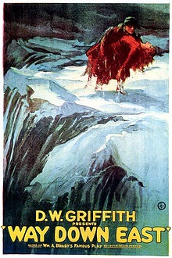
And despite his importance to cinema’s early development being unfairly forgotten by the time of his 1946 death, and the controversy that surrounds his most well-known film, D.W. Griffith should always be respected for the ideas that helped motion pictures achieve greater depth and substance.

