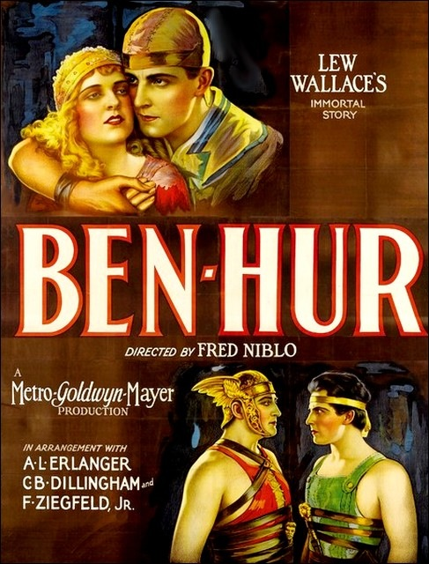
Name__________________ Period______ Date___________________
Singin' in the Rain is a 1952 American musical comedy film directed by Gene Kelly and Stanley Donen, starring Kelly, Donald O’Connor and Debbie Reynolds, and choreographed by Kelly and Donen. It offers a lighthearted depiction of Hollywood in the late '20s, with the three stars portraying performers caught up in the transition from silent films to "talkies."
Singin’ In The Rain
Directed by Gene Kelly
Stanley Donen
Cast
Gene Kelly as Don Lockwood
Donald O’Connor as Cosmo Brown
Debbie Reynolds as Kathy Selden
Jean Hagen as Lina Lamont
Millard Mitchell as R.F. Simpson
Douglas Fowley as Roscoe Dexter
Rita Moreno as Zelda Zanders
Madge Blake as Dora Bailey
Kathleen Freeman as PheobeDinsmore
Bobby Watson as Diction Coach
CydCharisse as “Broadway Melody” Dancer

Credits
Directed by Gene Kelly
Stanley Donen
Produced by Arthur Freed
Written by Betty Comden
Adolph Green
Music by Arthur Freed
Nacio Herb Brown
Cinematography Harold Rosson
Distributed by Metro-Goldwyn-Mayer
Release Date March 27, 1952
Budget $2.6 Million
Box Office $5.6 Million

The film was only a modest hit when first released, with O'Connor's Best Supporting Actor win at the Golden Globes, Comden and Green's win at the Writers Guild of America awards, and the best supporting actress Oscar nomination for Jean Hagen being the only major recognitions. However, it was accorded its legendary status by contemporary critics. It is now frequently described as one of the best musicals ever made,^{[3]} and the best film ever made in the “Arthur Freed Unit" at Metro-Goldwyn-Mayer. It topped the AFI’s 100 Years of Musicals list, and is ranked as the fifth greatest American motion picture of all time in its updated list of the greatest American Films in 2007.

Hollywood: Breaking the Sound Barrier

By Mark Juddery [1] | Published in History Today [2] Volume: 60 Issue: 7 [3] 2010

Mark Juddery looks at the historical backdrop to the much-loved 1950s Hollywood musical, Singin’in the Rain in which Hollywood tells its own story of the arrival of sound to the big screen.

Singin’in the Rain frequently appears high on lists of the ‘greatest’films ever made, whether voted by movie buffs, critics, or both (it was voted best on-screen musical by a 2006 American Film Institute poll and came eighth in Empire magazine’s 2008 best film poll). The reason seems quite simple: it is perhaps the finest and most enjoyable example of its genre. Halliwell’s Film Guide suggests that it has ‘the catchiest tunes, the liveliest choreography, the most engaging performances and the most hilarious jokes of any musical’. But its status as the greatest film musical was slow to take root.

When it was released in 1952, despite good reviews and box-office success, there were no such claims. At the time, musicals were in decline due to the burgeoning popularity of television. By the end of the decade the age of the ‘classic’movie musical –the modern-day, romantic fairytale with a score of popular songs to break up the (often wafer-thin) plot –was over. Since then, acclaimed musicals like West Side Story (1961), The Sound of Music (1965) and even nostalgic films like Chicago (2002) have seemed to belong to a different genre. Based on successful Broadway shows, despite their humorous moments, these had a darker edge.

Singin’in the Rain has an inventive plot, far more sophisticated than others of its era, but typical for its time it is ultimately a love story between Don Lockwood, an established screen actor attempting to adjust to the talkies, and the rising star Kathy Selden, played by the 18-year-old Debbie Reynolds. A Hollywood backstage comedy about an industry in transition, the film responded to a fashionable craze for 1920s’nostalgia.

When brainstorming ideas for the movie, associate producer Roger Edens played numerous 1920s’songs on the piano to the screenwriting team of Betty Comden and Adolph Green who, despite their background in Broadway musicals, considered themselves authorities on silent cinema.

‘All we began with was a skit about a movie star becoming a sound star,’said Gene Kelly, the co-director and star of the movie:
We all of us dashed around the studio asking the veterans what it was like in the old days and the script was built around the information we picked up. So what happened in the framework of the story was true. This is what it was like around MGM in 1928 –with a little comic exaggeration, of course.
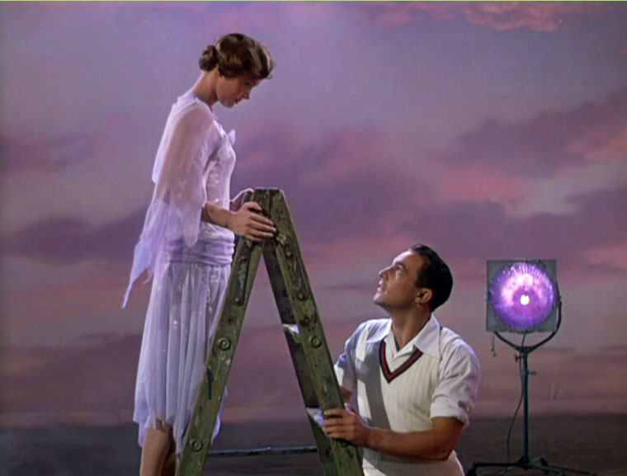
The art director Randall Duell and the set director Jacque Mapes scoured archival footage of MGM Studios to recreate a 1920s-style studio lot. Douglas Shearer, the head of the sound department at MGM, was consulted regularly by the directors Stanley Donen and Kelly about the hazards of early sound movie production. ‘Rarely has a musical been so accurately researched,’wrote Clive Hirschhorn in his 1974 biography of Kelly.

While Hollywood movies had boomed after the First World War, audiences in the 1920s were distracted by a new toy: the wireless. Through the medium of radio, they could be entertained without leaving home. It was the first serious rival to the cinema, with the advantage of sound. Meanwhile, moral campaigners, fuming about the ‘depravity’of the movies, were scaring families away from the cinema. Speculation was strong that, after 25 years of growing popularity, the film ‘fad’was finally waning.

Desperate to retain their audiences, Hollywood studios embraced the latest technology. Paramount spent $400,000 on a sound stage (subsequently destroyed by fire in 1929). Warner Brothers invested heavily in ‘talking pictures’, gambling $5 million on developing this technology (equivalent to about $62 million today) and adding a soundtrack to the previously silent medium. Their primitive sound-on-disc system was first used for Don Juan (1926), in which the actor John Barrymore’s gesturing was accompanied by a synchronised musical soundtrack. It was a great success, playing in New York for several months.
Warners’first feature-length ‘talkie’was The Jazz Singer (1927). This was basically a silent film with a few moments of synchronised sound and improvised dialogue between the star, veteran black-face entertainer Al Jolson (considered by Warners–and many others –to be the ‘world’s greatest entertainer’) and Eugenie Besserer, who played his mother (or his ‘mammy’, as he sang to her in the film’s best-known song). While the plot was no more sophisticated and no less melodramatic than the average silent movie, audiences were drawn to songs like Gus Kahn’s Toot Toot Tootsie Goodbye and Irving Berlin’s Blue Skies.
Singin’in the Rain portrays the movie industry’s initial, mostly negative response to talking pictures. ‘It’s vulgar,’remarks the exotic Olga Mara, a character based on the Polish-born silent movie star PolaNegri, who in 1927 had dismissed talkies as ‘a fad, a curiosity’. Reading the trade newspaper Variety, one of the actors notes that The Jazz Singer is an ‘all-time hit in the first week’. ‘All-time flop in the second,’another character responds. The reaction was not uncommon in Hollywood, which –faced with re-learning the art of the cinema –lived in denial. The film implies that within a very short time, perhaps a few weeks, studios were closed, fully rewired with sound equipment and reopened. Though not quite so prompt, every significant American studio had talking pictures in production by the end of 1929. The first ‘100 per cent all-talking’film, Lights of New York, was released in July 1928. It was an immediate hit despite technical flaws (causing Variety to call it ‘100 per cent crude’).

Early sound equipment was awkward and often defective. In smaller cinemas, the dialogue was frequently unintelligible for the first ten minutes. But clumsy as they were, the talkies saved the medium. Between 1927 and 1930, box-office takings (which had been falling considerably) increased by 50 per cent. Still, some in the industry hoped that this was just a short-lived craze. Charlie Chaplin, the most famous comedian of the time, brashly predicted in 1929 that the talkies would not last a year. He also said that, as a ‘pantomimist’, he would never make one. Alone among Hollywood producers he continued to make silent films, refusing to make a talkie until 1940.

Others did not have that luxury. According to the director Ernst Lubitsch (1892-1947), producers made a call to their stars and directors:
And the producers said, ‘You ladies and gentlemen who are the stars of the great silent screen, you must now learn to talk. You can no longer make faces and look camera left, camera right, up, down, what the director tells you to do, and then hope that he can put it together into a performance. You’ve got to learn to talk dialogue, to sustain scenes, to characterize, to remember dialogue and to play it. Those of you who can, you’ll be greater than ever. Those of you who can’t –overnight, no matter how great you are, you’ll be finished.’

In true Hollywood style, Lubitsch’s recollections were melodramatic and somewhat exaggerated.

Singin’in the Rain tells the story of two fictitious stars as they cope with the coming of the talkies. Don Lockwood, played by Kelly, a dashing star in the Douglas Fairbanks mould, is a former vaudeville singer and dancer. As such, he easily adjusts to using his voice. His leading lady, Lina Lamont, played by Jean Hagen, is not so lucky. Though suitably glamorous, she is saddled with a shrieking voice and poor diction that are quite unsuitable for the historical heroines for which she is renowned. One of the more memorable villains of movie musicals, the scheming Lina is in part brought down by her own bloated sense of stardom. According to Kelly, she was based partly on Mae Murray, a notoriously temperamental star of the silent era, known off-screen for mangling the English language. In the end, Lina’s career is over, while Kathy becomes Don’s leading lady both on and off the screen.

Lina’s fate, however, mirrors that of the actress Norma Talmadge, whose strong Brooklyn accent was completely at odds with her well-honed image as an elegant star of the silver screen. She retired immediately after the release of her first talkie, Dubarry, Woman of Paris (1930), as her fans tried to recover from hearing her voice.

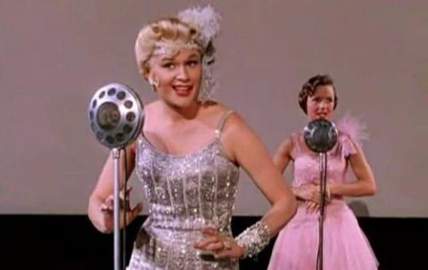
‘That microphone was a nemesis: if you didn’t record well, you were finished,’recalled the screenwriter Joseph Mankiewicz. He described when a fire broke out one day at Paramount studios, Clara Bow screamed: ‘I hope to Christ it was the sound stages. The response from performers and their employers was close to panic. Actors were submitted to ‘voice tests’and enrolled in singing lessons. As Singin’in the Rain noted, they were also sent to expensive elocution lessons, in which each word was painstakingly recited. This resulted in cultured voices that were often at odds with their on-screen personae. Even ‘good time girls’like Clara Bow (the original ‘It Girl’) and Colleen Moore (the archetypal 1920s’flapper) were given extensive vocal coaching to sound more refined, in the style of serious theatre actors. After all, they would be up against the likes of Broadway actress Ruth Chatterton, who was among the stage elite now brought to Hollywood to add class to the movies.

Some silent stars faced with the microphone took up the challenge with gusto. Make-up maestro Lon Chaney, known as ‘the man of a thousand faces’, was now forced to be the man of a thousand voices as well. Though initially reluctant (avoiding talkies longer than any major star other than Chaplin), he used five different voices for his first talking picture, The Unholy Three (1930), then died of cancer at the age of 47.

Mary Pickford, long known as the ‘queen of Hollywood’, spoke in a deep southern accent for her first talkie, Coquette (1929), which won her an Oscar (after a blatant campaign). The comedienne Marion Davies, an accomplished mimic, made her debut in Marianne (1929) with a convincing French accent. Davies had enough vocal challenges already, as she was known to stutter –an obstacle that would never be apparent in her movies.A number of characters in Singin’in the Rain are based on popular figures of the silent era. Gossip columnist Dora Bailey, who speaks the opening lines, is inspired by the Hearst newspaper columnist and critic Louella Parsons. Fun-loving silent star Zelda Zanders (‘the Zip girl’), played by a young Rita Moreno, was based on Clara Bow. The long-legged vamp in Kelly’s Broadway Melody ballet sequence, played by dancer CydCharisse, was a tribute to silent actor Louise Brooks, complete with her renowned ‘bob’hairstyle. Kathy Selden was not modelled on a 1920s’star but was conceived as ‘full of saccarine’and compared with June Allyson, a popular MGM musical star in the late 1940s. (Allyson was suggested for the role but at 34 was considered to be too old.) The only genuine silent film star appears in the most famous scene, as a man to whom Kelly hands his umbrella after his joyous rendition of the title song. This extra was the Australian-born comedian Snub Pollard, bestknown as Harold Lloyd’s co-star in the slapstick Lonesome
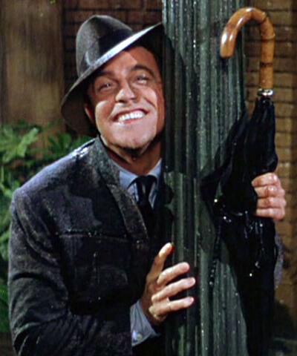
Luke series.

Those silent stars with foreign accents were among the swiftest victims of the talkies, though for some, such as the Hungarian VilmaBanky and Mexican Lupe Velez, whose thick accents were surely no surprise to audiences, they added a certain exotica. MGM promoted Greta Garbo’s first talking picture, Anna Christie (1930) by splashing the words ‘Garbo Talks!’over thousands of billboards. Once her voice was heard, with its Swedish tones and deep inflections, she was more popular than ever.

Some of the stars whose careers faded with silent movies were perhaps victims of house-cleaning, as studio heads saw the arrival of sound as an opportunity to start afresh. Actors who had fallen prey to scandal (Mabel Normand), had angered their bosses (John Gilbert), or were simply past their prime were dismissed. ‘I knew that unless I proved I could talk before my contract expired,’said Pittsburgh-born actor AdolpheMenjou, ‘I would be a dead pigeon.’Menjou adopted a French accent to match his name and his continental looks. His career survived for another 33 years.

‘Sound democratised the stars,’wrote film historian Alexander Walker, ‘by making them identifiable members of contemporary society and not dream figures existing in the audiences’collective unconscious.’Many of the new stars, fittingly, were lured from the theatre and radio. In the late 1920s, the talkies introduced numerous stage actors to the movies: Gary Cooper, Charles Laughton, John Wayne,Maurice Chevalier, Ray Milland, Jean Harlow and the Marx Brothers, to name but a few. In place of ‘scenarists’(as writers of silent film scenarios were called) came noted playwrights and authors, from Ben Hecht to F. Scott Fitzgerald, and many Broadway plays were soon translated into film. But, as with the silent film actors, the Hollywood writers adapted. The scenarists, originally kept in the studios to show the newcomers the ropes, learned to apply their craft to writing entire screenplays, taking advantage of the cinematic medium far more than the Broadway playwrights who thrived on the limitations of the stage.
Many of the comic routines in Singin’in the Rain came from true stories. The laughter that greets Don Lockwood’s improvised dialogue (‘I love you, I love you, I love you, I love you …’) was inspired by audiences’response to John Gilbert delivering the same lines in the corny, scripted dialogue of His Glorious Night (1929). Though some criticised his voice for being too high, it has been suggested that while happy to see a love scene enacted in silence, others who experienced the early talkies were embarrassed to listen to such mawkish dialogue.

Sound recording picked up many noises: the whirr of the cameras and arc lights (forcing them into sound-proof booths), radio interference, even the chatter of the cast and crew, used to being able to talk while filming went on. The sound engineers, who had come to the movies (a medium about which most knew little) from an audio recording background, were forced to improvise in the studio, leading to such incidents –retold in Singin’in the Rain–as recorded heartbeats and microphones hidden in props (provoking Lina’s exasperated line ‘I can’t make love to a bush!’). Experienced technicians were also convinced that it was impossible to film outside the studios –a belief that was challenged when veteran film director John Ford, unable (or unwilling) to appreciate the logistical problems, insisted on shooting part of the comedy Napoleon’s Barber (1928) on location. To the engineers’surprise they were able to do it. Most of the filming, however, still took place in the studios, now rebuilt as sound-proof boxes. Delighted with their new found ability to make musicals, Hollywood studios churned out so many in 1929 and 1930 that the novelty soon wore thin.
Film buffs have pondered which Hollywood tycoon was the basis for R.F. Simpson, the head of the fictitious Monumental Pictures, in Singin’in the Rain, played by the character actor Millard Mitchell. However, Simpson was reportedly based on the lyricist Arthur Freed, who wrote songs for MGM musicals for a decade before becoming a producer of screen musicals, including The Wizard of Oz, On the Town and Singin’in the Rain.

The song Singin’in the Rain, written by Freed and Nacio Herb Brown, was first performed by an all-star cast of former silent film actors including Marion Davies, John Gilbert, Bessie Love and Buster Keaton in MGM’s bizarre variety show film The Hollywood Revueof 1929 (which showed that established stars weren’t merely required to talk, but also to sing and dance –something that, in many cases, they couldn’t do very well).

Though written in the 1920s and 1930s most of the songs in Singin’in the Rain are arranged and performed in a contemporary 1950s’style. The exception is a short medley in which excerpts from numbers like Freed and Brown’s I’ve got a Feelin’You’re Foolin’ and The Wedding of the Painted Doll are crooned over a series of abstract and colourful images focused around a chorus of smiling flappers. This segment parodied the musical numbers of dance director Busby Berkeley, famous for his dance spectaculars, featuring scores of beautiful young women who ornamented mid-1930s’musicals such as Footlight Parade and the Gold Diggers series. At the time this was the kind of escapism that Depression-era audiences craved. The frenetic film director in Singin’in the Rain, played by Douglas Fowley, was purportedly based on Berkeley, though Berkeley (unlike his fictional equivalent) did not start out as a silent movie director. He was making Broadway shows when he first moved to Hollywood in 1930.

With its affectionate parodies of Berkeley's musical numbers, as well as other early musical films, Singin' in the Rain went full circle. The polished, comparatively hi-tech versions of popular songs recorded in a 1952 style have little in common with the almost muffled versions heard in movies such as The Broadway Melody (1928) and Going Hollywood (1933). Taking the best songs and concepts of these movies, Singin’in the Rain is now seen by many connoisseurs as the apex of the musical genre. While celebrating the past, it also showed the way forward. Previously, movie musicals had been considered simple escapism. By the end of the 1950s, the genre was known for quality cinema and the 1958 romance Gigi (regarded as the last of the great MGM musicals) won eight Oscars.

Singin’in the Rain is one of the wittier examples of Hollywood turning the microscope on itself. Many of the best films about the movie industry –The Last Command (1928), A Star is Born (1937), The Aviator(2004) –have been surprisingly downbeat. Even the great satirical films about Hollywood, such as Sunset Boulevard (1950) and The Player (1992), suggest an insider’s view of this world that is somewhat desolate. Singin’in the Rain, however, was a lighter take on the industry, driven (like many MGM musicals) by nostalgia for an allegedly simpler time.

The progress of Singin’in the Rain from popular genre film to renowned masterpiece was gradual. In 1988 John Kobal surveyed an international group of film critics on the top films ever made. This list had little in common with the buffs’list of Empire magazine, but after such ‘art house’movies as Citizen Kane and Battleship Potemkin, Singin’in the Rain surprised many by being ranked fifth overall, proving that even film critics can have fun. It was, after all, an impressive technical achievement, using the state-of-the-art facilities of 1952 to showcase the formidable talent involved.
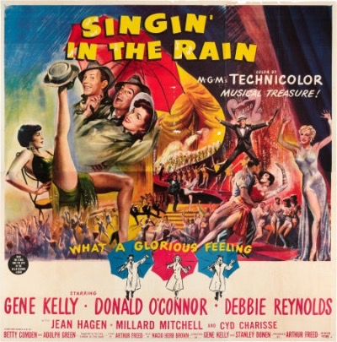
Despite its obvious affection for the silent era of the movies, Singin’in the Rain makes it clear where its heart lies: in the all-singing, all-dancing, all-wisecracking cinema that followed.

Source URL:http://www.historytoday.com/mark-juddery/hollywood-breaking-sound-barrier

Comprehension Questions

Unlike other film guides we have completed so far, you may find you have to wait until the end of the film to answer these questions. Please be thoughtful as you answer these questions. They should be difficult to answer in just one sentence. An explanation of your answer is necessary.

- How does Don Lockwood change as the movie progresses? What forces are at work in this change?

- What function does Cosmo serve in the story? Why include the proverbial “third wheel”? Why is there no love interest for Cosmo?

- Which characters change and evolve? Which stay stagnant? Why?

- What are the impediments to Don and Kathy’s relationship? How are they overcome?

- How are songs used dramatically and cosmetically to propel the story and to reveal character?

6. The film’s key musical performance- and the single most memorable dance number in cinematic history- is the Singin’In The Rain”sequence. As you watch this scene, consider the following questions:
- How does this sequence exemplify Kelly’s interest in using dance as an “expression of character’s moods and feelings.”How does this musical number illustrate Lockwood’s mood- and his emotional development- at this particular moment in the narrative?

- How does this sequence illustrate what Peter Wollen describes as an “escalation of movement?”In other words, how does Kelly- and the camera that follows him- become more active and vigorous as the number progresses?

- What function does the lengthy “Broadway Melody”sequence serve to the story and characters?

- How are the plot elements connected and then resolved in the final climactic scene?

Discussion Questions

- How do camera work and editing integrate with music and performance to help tell the story and evoke emotion?

- What part does color play in evoking emotion, defining character and setting mood?

- How are dance sequences shot and edited for maximum impact?

- What techniques are used to suggest the style of silent movies of the time in which the movie is set? of early sound movies?

- What style of lighting is used in the movie and what effect does it have?

- How do the filmmakers use studio sets and back lots to stylize the world of the film? To stylize the “Broadway Melody”sequence?

- Singin’in the Rain, like all movies, is about life, not just about making movies. Since classic Hollywood films were meant to support social values, they were designed to showcase characters who modeled socially desirable traits. What admirable qualities does Don Lockwood have? What cluster of values does Kathy Selden represent? Lina Lamont? How are Don’s dilemma and its solution marked by his acceptance (or rejection) of those values? What life lessons are we meant to learn from this film?

