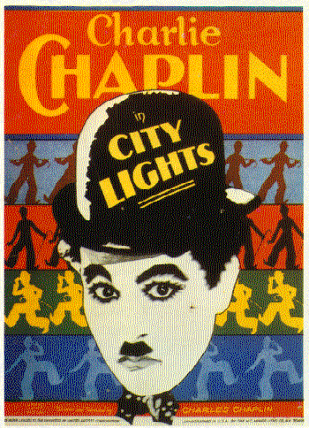
Name__________________ Period______ Date___________________
City Lights (1931)
Directed by Charlie Chaplin
Cast
Virginia Cherrill as A Blind Girl
Florence Lee as Her Grandmother
Harry Myers as An Eccentric Millionaire
Al Ernest Garcia as His Butler
Hank Mann as A Prize Fighter
Charlie Chaplin as A Tramp

Credits
Directed by Charlie Chaplin
Produced by Charlie Chaplin
Written by Charlie Chaplin
Music by Charlie Chaplin
Cinematography Rollie Totherot
Gordon Pollock
Mark Marklatt
Distributed by United Artists
Release Date January 30, 1931
Budget $1.5 million
Box Office $5,019,181

City Lights is a 1931 American romantic comedy film written by, directed by, and starring Charlie Chaplin. The story follows the misadventures of Chaplin’s tramp as he falls in love with a blind girl (Virginia Cherrill) and develops a turbulent friendship with an alcoholic millionaire (Harry Myers).
Although sound films were on the rise when Chaplin started developing the script in 1928, he decided to continue working with silent productions. Filming started in December 1928, and ended in September 1930. City Lights marked the first time Chaplin composed the film score to one of his productions and it was written in six weeks with Arthur Johnston.
City Lights was immediately successful upon release on January 30, 1931, with positive reviews and box office receipts of $5 million. Today, critics consider it not only one of the highest accomplishments of Chaplin's career, but one of the greatest films ever made. In 1992, the Library of Congress selected City Lights for preservation in the United States National Film Registry as being "culturally, historically, or aesthetically significant". In 2007, the American Film Institute’s 100 Years…100 Movies ranked City Lights as the 11th greatest American film of all time. In 1949, the critic James Agee referred to the final scene in the film as the "greatest single piece of acting ever committed to celluloid.
It was 1928, just months after the first talkie had hit theaters, and Charlie Chaplin’s life was a mess. He’d recently been through a highly publicized divorce. His ex-wife was selling stories to tabloids detailing his many affairs. The IRS was hounding him for $1.6 million in unpaid taxes. On top of his private woes, Chaplin’s career was on the ropes. As talking pictures swept the nation, silent film—the art form he’d elevated to new heights—was flickering out. In the last few years, major studios had stopped investing in the medium, and Charlie Chaplin, the world’s biggest movie star, had considered retiring.
But instead of packing it in, Chaplin decided to fight back. He wanted to produce one final movie that would put talkies in their place and showcase “the great beauty of silence.” When no one would finance his picture, he doubled down on his bet, cashing out his entire stock portfolio to finance it himself.
“Nothing could deter me from making it,” Chaplin said. Yet, 18 months and $2 million into shooting City Lights, Chaplin found himself wading in unfamiliar waters.
more
He’d never spent this much time working on a picture. Hits such as The Gold Rush (1925) and The Circus (1928) had been shot and stitched together effortlessly. But as the clock ticked and silent film became increasingly outdated, Chaplin’s anxiety rose. He fired his lead actress. He canceled shoots. He left actors waiting on set for full days at a time. Instead of a movie, he had a patchwork of disjointed scenes and sight gags. Hollywood insiders had already written him off, publicly proclaiming his downfall. For Chaplin, the stakes couldn’t have been higher. The fate of his career hinged on the success of this film.

A SIGHT FOR BLIND EYES

From the beginning, Chaplin knew City Lights would be about blindness. His original plot involved a circus clown who loses his sight, then must hide the fact from his sickly child. After tweaking the concept, Chaplin settled on an idea he liked better: his signature character the Tramp would fall in love with a blind flower girl, then try valiantly—and comically—to help her restore her sight. Along the way he’d befriend a drunk, enter a boxing match, get a job, lose that job, party with millionaires, get mistaken for a burglar, and land in jail. But not before coming to the flower girl’s rescue.
Chaplin’s biggest hurdle was finding a girl “who could look blind without detracting from her beauty.” He rejected nearly 20 actresses before discovering Virginia Cherrill sitting ringside at a boxing match. As he studied the 20-year-old society girl, Chaplin thought she was blind. It turned out she was just extremely nearsighted and had refused to wear glasses out of vanity. Chaplin didn’t mind that she had no experience as an actress. As a Svengali-like auteur, he routinely molded his costars with explicit directions about every gesture and expression. One of the young actors who played a street tough in City Lights opined, “I think Charlie would’ve much rather played all the parts himself if he could.”

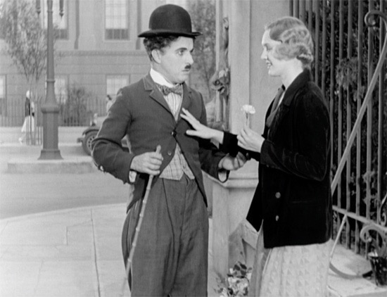

Working with Chaplin could be exhausting. While the director was fair in many regards—he was scrupulous about paying the crew for their time—he was also erratic. Of the 534 days scheduled for filming on City Lights, Chaplin only filmed on 166. When he did shoot, he ran the cast ragged. The director demanded perfection, and his lead actress suffered the most. Chaplin hounded her. He belittled her. He drove her through 342 takes on a single scene alone. When Cherrill bristled, he called her an amateur. Then one day, when she returned late from lunch, he fired her. Chaplin recast the part with his Gold Rush leading lady Georgia Hale.
Before long, Chaplin realized his mistake—the time spent directing Hale and the cost of reshooting Cherrill’s scenes would set him back too far. In desperation, he re-hired Cherrill, though now at twice her original salary. The friction between the two leads was palpable, and it wasn’t just about money. As Cherrill said, “Charlie never liked me, and I never liked Charlie.” Yet, none of that animosity shows on screen; their scenes together are heartbreakingly tender, and some of the most extraordinary in all of cinema.

THE BET ON THE TABLE
For City Lights to truly outshine the talkies, Chaplin knew he couldn’t rely on gags alone. In previous films, he’d built thin scripts around a series of vaudeville set pieces. This time he insisted that plot and characters drive the action—a modern notion for comedies. He also retooled his storytelling: Chaplin interweaved the pathos and comedy to wrench more emotion from each scene. When a lonely millionaire contemplates suicide, it’s tragic. When the Good Samaritan Tramp attempts to save him from drowning, and accidentally ends up with a weight pinned to his own neck, the laughs come quickly.

For Chaplin, even the use of sound had to be innovative. In one scene, the Tramp accidentally swallows a penny whistle during a performance, then tries to contain himself as he hiccups an aria. This wasn’t standard “Mickey Mousing,” or punctuating a gag with a sound effect; Chaplin was doing something novel—using sound as the punchline.
Chaplin took nearly three years to complete City Lights. But even with a great film in the can, the odds were stacked against him. Despite his incredible track record, theaters had a wait-and-see attitude before they’d commit to screening the film. For its New York City debut, Chaplin was forced to roll out City Lights with a soft opening at an “off the beaten path,” “white elephant” movie house. Determined to make the film a success, Chaplin took over the movie’s PR and marketing. He dyed his hair. He talked up his fitness routine to reporters to prove he was still in his prime. And he sank $30,000 (equivalent to nearly $500,000 today) into buying newspaper ads, hiring ushers, and even having a new electric marquee installed at the theater. Chaplin obsessed over every detail. But ultimately, the public would decide.

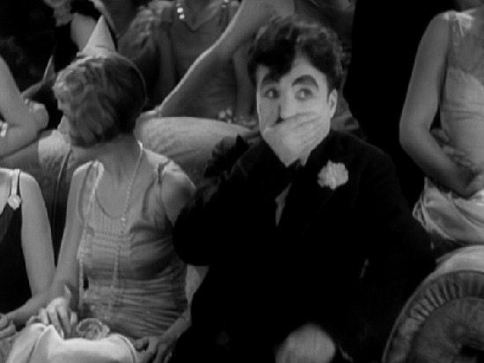

LEGACY
When City Lights finally debuted in New York in 1931, the reaction was overwhelmingly positive. The film was so popular that the theater had showings from 9 a.m. to midnight continuously, every day except Sunday. According to historian Charles Maland, “by the end of 1931, the [United Artists’] ledgers reveal, City Lights had already accumulated more domestic rentals than The Circus and over 90 percent of the domestic rentals that The Gold Rush had garnered since 1925.” Critics showered praise as well. The New York Times declared, “Mr. Chaplin’s shadow has grown no less.”
For a short period, it seemed that Chaplin had accomplished what he set out to do. Studios invested in silent pictures again. Screen legend Douglas Fairbanks Sr. talked excitedly about returning to the medium. And in 1931, the Oscar for Best Cinematography went to another silent film, Tabu. Many expected City Lights to nab the award, but it wasn’t nominated. As film historian William M. Drew wrote, “Perhaps Chaplin’s perceived audacity in persisting in making a silent film in Hollywood after sound had arrived ... seemed too great an act of insubordination for the industry to honor.”
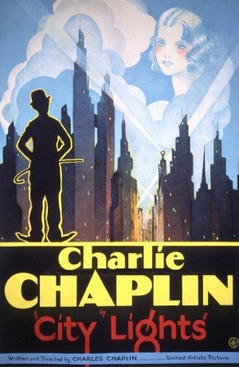
But the swing back to silent films could never last. In a 1973 interview with director Peter Bogdanovich, Chaplin confessed that City Lights was his favorite of his films. Indeed, it’s often declared “the most Chaplin” of his movies because it bridges all of his strengths—the highbrow and the low, the serious and the slapstick. And while City Lights is considered the last of Chaplin’s silent films (it had sound, but no speech), the film marks the first time the director used his camera as a soapbox. As the Tramp pinballs between the worlds of the rich and the poor, Chaplin is highlighting the issues of the class divide. City Lights kick-started Chaplin’s move both to more political films, and to a more political life. In 1936, Modern Times voiced his anxieties about industry and society. And in 1940, Chaplin used The Great Dictator to bullhorn his opposition to Hitler.
But what makes City Lights a masterpiece isn’t its politics, or its silence, or even the fact that countless later movies have borrowed from it. What makes City Lights special, quite simply, is the story.

from http://mentalfloss.com/article/30080/masterpieces-charlie-chaplins-city-lights

Comprehension Questions

- Why does the blind girl think the tramp is a millionaire?

2. How does the background music in this movie drive the story and the plot?

3. Why does the tramp keep the millionaire from killing himself?

4. Who do you think is the primary audience for this movie?

5. How are the wealthy portrayed in this movie? Why are they shown partying so often?

6. Why does the tramp fall in love with the blind girl?

7. Why doesn't the millionaire recognize the tramp when he is sober?

8. Does the tramp want to be respected and seen like a gentlemen?

9. Why doesn't the tramp like work?

10. Are there times in the movie where people don't see the tramp, and they blindly walk around him?

11. How does the tramp approach people after getting out of jail after serving time for robbery?

12. Does the blind girl, who can now see, fall in love with the tramp when she recognizes him? Did she already love the tramp?

13. What does the blind girl mean when she tells the tramp, "I can see now”?

14. Does the tramp hope that the blind girl, who can now see, will still love him even if he is just a tramp?

Discussion Questions

- This film was produced in 1931, four years after The Jazz Singer, and during a time when theaters had converted to sound. Why do you think Charlie Chaplin was determined to make this a silent picture?

- Charlie Chaplin was considered one of the greatest comics of his generation. He was one of the first movie stars. Having watched what many consider to be his masterpiece, what do you think of him as a comic, an actor, and a filmmaker? This is a three part question. Would you watch more Chaplin if given the chance?

- City Lights is considered to be a profoundly deep film. What theme do you think Chaplin is trying to communicate about life and relationships?

- Compare City Lights to Way Down East, the first film you watched. How has filmmaking changed over the course of these ten years? What does the camera do that it didn't do in its early years? How has story telling in film changed over those ten years?

- You have watched four silent films over the last four weeks of class. Do a bit of self reflection. What do you think of silent films? Do you like them? Why or why not? Have you been at all surprised by what you have seen? Explain. Finish your reflection by explaining what you have learned so far about movies, filmmaking as an art, and how you traditionally watch a movie? Be prepared to share this response with the class. ALL participants will share their response.

