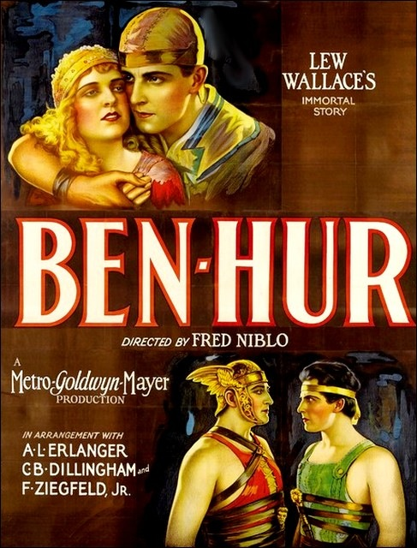
Name__________________ Period______ Date___________________
Ben-Hur (1925)
Directed by Fred Niblo
Cast
Ramon Novarro as Judah Ben Hur
Francis X. Bushman as Messala
May McAvoy as Esther
Betty Bronson as Mary
Kathleen Key as Tirzah
Carmel Myers as Iras
Nigel De Brulier as Simonides
Mitchell Lewis as Sheik IIderim
Leo White as Sanballat
Frank Currier as Quintus Arrius
Charles Belcher as Balthazar
Dane Fuller as Amrah
Winter Hall as Joseph

Credits
Directed by Fred Niblo
Produced by Louis B. Mayer
Written by June Mathis
Carey Wilson
Bess Meredyth
Cinematography Clyde De Vinna
Rene Guissart
Karl Struss
Distributed by Metro-Goldwyn-Mayer
Release Date December 30, 1925
Budget $3,967,000
Box Office $10, 738,000

With a budget of nearly $4 million, Ben-Hur was the most expensive film of the silent era. This adaptation was the second screen version of American soldier Lew Wallace’s massive novel (1880) of the same name. In 1907 the story had been condensed into a one-reel short. The highlight of the 1925 version is the famed chariot race. Initially, the cast and crew traveled to Italy for location filming, where the epic film ran into problems immediately. Conditions were unfavorable, a stuntman was killed, and the budget began to skyrocket. The crew relocated to Culver City, Calif., where the racetrack was reconstructed with more notable results. Critics still regard the scene as one of the most impressive action sequences in film history. Equally massive in scale was the major sea battle, shot on location in Italy. Several of the main scenes were shot in two-strip Technicolor, a true innovation for those days.
For the fledgling Metro-Goldwyn-Mayer (MGM), the film ensured the studio’s reputation as a major player in the film industry. William Wyler, an assistant director on this version, would win an Academy Award for his direction of the acclaimed 1959 MGM remake.

To be sure, BEN-HUR had been filmed before. In 1907, the Kalem Company made a 20 minute version of General Lew Wallace's sprawling Biblical epic by stealing some shots of a mock chariot race at a fireworks show at Sheepshead Bay, Brooklyn, and adding some interiors. But this was not the prestige production that the brand-new Metro-Goldwyn-Mayer movie combine had in mind to announce itself as a major producer in 1925. Yet the announcement of MGM's arrival was almost a herald of disaster.
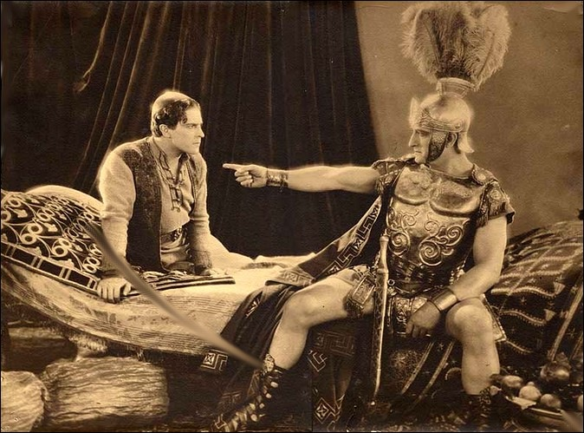
BEN-HUR was a huge success as a novel, and also as a stage play. Stage productions had been running for twenty-five years when MGM got into the act. The play's vast scenes and giant cast required treadmills, a sea battle, eight horses, and a Roman legion of technicians. In spite of its costs (only the largest theaters in the land could stage it) the play Ben-Hur became the most profitable theatrical production in American history. Now, in the wake of such imported cinematic epics as the Italian films CABIRIA (1914) and QUO VADIS (1915), and the success of the distinctively American THE BIRTH OF A NATION (1915), Hollywood felt up to the task of screening this most famous of properties. It wouldn't be easy, and everything about BEN-HUR took on the scope of epic drama.

To begin with, the play's producer, Abraham Erlanger, put a heavy tariff on the screen rights, in which everyone from D.W. Griffith to Adolph Zukor of Paramount had expressed an interest. The initial asking price? One million dollars. Eventually, Erlanger was persuaded to accept a generous profit participation deal and total approval over every detail of the production. Negotiations began in 1919, and wound their way through several studios. Every major director in Hollywood was considered, including Erich von Stroheim, and Rex Ingram of FOUR HORSEMAN OF THE APOCALYPSE fame, before Charles Brabin, a noted director of the day, was settled upon. By the time Metro Pictures, MGM's predecessor, was finally chosen, a crucial element had been added to the project: in an age when 'going on location' usually meant a trip to White Plains or Santa Monica, BEN-HUR would be shot in Italy, for maximum authenticity.
Immediately, the production was beset with delays. When historian Kevin Brownlow interviewed members of the cast forty years later, he found them still shaking their heads in disbelief. Star Francis X. Bushman, who was to play Messala, was told on his arrival that his scenes wouldn't be shot "until next August." Bushman availed himself of a trip around Europe so leisurely that he had time to visit twenty-five countries before he was called back. The building of BEN-HUR's sets by Italian craftsmen was slowed by labor disputes, and foot-dragging on the part of the country's new leader, Benito Mussolini, who saw a lovely opportunity to embarrass the Americans. The film's sea battle, which was intended to rival the trademark chariot race, proved nearly impossible to mount. When Bushman returned to the sun-baked set at Anzio, he found that the relaxed Italian climate and attitude had proved infectious. Production was completely stalled, Brabin's work ethic having melted under the Italian sun. Of Brabin, Bushman recalled that "all the time he was telling stories and drinking wine. I didn't realize that out on the beach he had hundreds of extras roasting and doing nothing.”

Shipyards had completed only twelve mock-ships of the planned 70-vessel fleet, but Brabin decided to go ahead with the sea battle. What resulted was laughable, and MGM revamped the entire production after seeing the rushes. Many of the leading roles were recast; Ramon Navarro was now to play Ben-Hur, and Fred Niblo replaced Brabin, who must have been grateful. Months went by. The sea battle sequence was readied again, this time at Livorno, but now, new problems loomed. Niblo discovered that some of the prop swords had been sharpened, and that extras had divided themselves into fascist and anti-fascist contingents. The battle went off as planned, but, during the ramming and burning of the Roman flagship, some of the terrified Italian extras began jumping overboard in fear. Weighted down by armor, many of them unable to swim, several extras could not be accounted for when a head count of the soaked survivors was taken on shore. When Bushman asked a wardrobe assistant what had happened, the man could only say, "Ah, Mister Bushman, many costumes missing. . . " An international incident seemed in the offing, and one assistant director volunteered to row out to sea with enough chains to permanently sink any bodies that might bob up.
The missing extras turned up, but the rest of the shoot was nearly as agonizing. The raft scenes took days to shoot, and Navarro was only able to keep the elderly actor playing Quintus alert by slapping his face and pouring brandy into him. Excavation for a set revealed Roman catacombs filled with valuable antiquities, which were looted. Politics kept the carpenters divided into warring factions. (Bushman believed that the strikes which constantly bedeviled the company were orchestrated by Mussolini.) When the workers discovered that the production might actually end, they slowed construction of the huge Circus Maximus set to a crawl; after all, some of them had now made a career out of BEN-HUR.
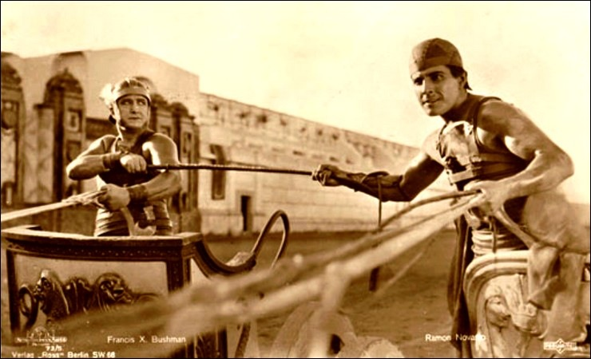
The worst agonies were reserved for the film's climax, the chariot race. Legendary second unit director B. Reeves Eason's nickname "Breezy" was certainly not earned by his work on the BEN-HUR set, for his merciless pace cost the lives of over a hundred horses. As Bushman said sadly, "If it limped, they shot it." A stunt man was killed in a chariot crash, and Navarro himself only narrowly escaped death. The madness ended for a while. The company had spent a year in Italy, and there was still material to be shot, or reshot, in the case of the entire chariot race, with which MGM leadership was still not satisfied. The crowd scenes and master shots for the race were done in a single day, with forty-two cameras covering the action. (One of the thousands of extras was a bewildered William Wyler, who would direct the 1959 remake of the film.) Shooting continued for weeks, until Eason, heedless of danger, had gotten exactly the detail shots he wanted to make the chariot race one of the most exciting action sequences ever filmed. Quietly, out of sight of the ASPCA, the toll among horses continued to rise.
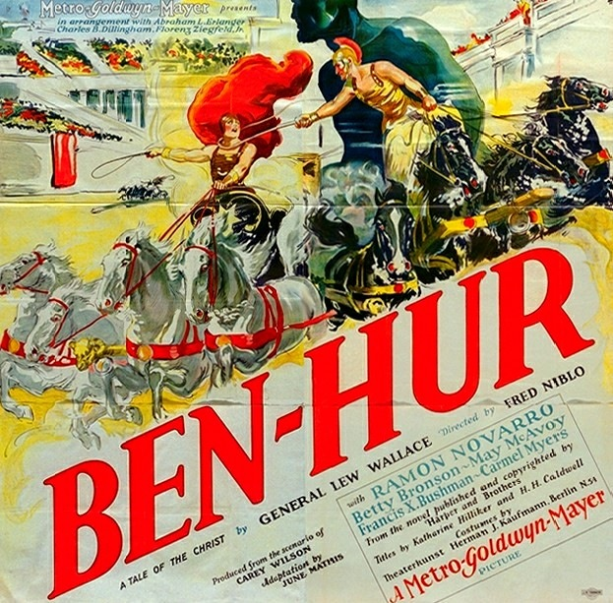
Finally, it was over. BEN-HUR opened in late 1925 to tepid reviews and a torrid box-office. Although the picture grossed nine million dollars, its huge expenses and the deal with Erlanger made it a loser for MGM, in spite of the brilliant shamelessness of the studio's publicity department, which advertised the film with lines like, "The Picture Every Christian Ought to See!" Mussolini banned the film in Italy when he discovered that the Roman Messala hadn't been able to cover the spread on the chariot race. No matter. BEN-HUR had done exactly what the new company asked of it, and for another quarter century, the name MGM was to signify quality at any expense. But Hollywood had learned a lesson about location work, and for that same quarter century, it preferred to build everything from the Vatican to the Alamo on its own backlots, where life wasn't quite so harrowing, and the swords weren't quite so sharp.
— Kevin Hagopian, Penn State University

Comprehension Questions
- The first 15 minutes of Ben Hur is a retelling of the story of the birth of Christ. The story is presented through the use of tinting and 2 strip Technicolor. Before we are ever introduced to the character of Judah Ben-Hur, we are given a majestic presentation of a bible story. What do you think will be the importance of the Christ character to the character of Ben Hur?

- Describe the social system of the day? Who were in control and who were the oppressed? Why is this important to remember as the movie continues?

- Notice that when we see Judah Ben-Hur for the first time, he is moving along as the Roman soldiers and people move behind him. The camera moves to keep the character in the center of the picture. Of what importance can you infer that the Roman armies and characters may have to the character of Judah Ben-Hur?

- When Judah meets Esther, does he know that she is the daughter of one of his slaves? Why might this be an import an plot device later in the movie?

- Explain the relationship of Messala and Judah Ben-Hur? Why is Messala ashamed of his relationship with Judah?

- What event permanently destroys Messala and Judah’s friendship, casting them against one another? How does it change the course of Judah’s life?

- How does Niblo (the director) use the camera and editing to portray Judah’s suffering, Christ’s compassion, and the cruelty of the Roman captors?

- Why does Quintus Arrius notice Judah Ben-Hur? What seems to set him apart from the other galley slaves?

- What event changes the course of Judah Ben-Hur’s life yet again? Whose life does he save in the process?

- When Judah Ben-Hur climbs up the side of the Roman ship, and peers into the porthole at the galley slaves, what do you infer he is thinking?

- What has become of Judah Ben-Hur’s mother and sister? Why does Ben-Hur continue to search for them? Contrast Judah Ben-Hur’s present life to that of his sister and mother.

- Why do you suppose the Jewish people believed that the messiah would lead armies? Why are the people not looking for one who spoke of peace, but war?

- Why does hearing the name of Messala change Judah Ben-Hur’s mind regarding driving the chariot for the sheik?

- How do the camera angles and the editing of the chariot race add to the dramatic narrative of the movie?

- How does the director Fred Niblo give depth and emotion to the character of the mother in the scene where she is at the side of the sleeping Judah Ben-Hur? Why does she let him sleep?

- How is Judah Ben-Hur misguided and confused when he gathers a legion of armies to assist the Messiah, the King? What does he believe Jesus has been sent for?

- Why is the conversion of Judah Ben-Hur important to the climax and resolution of the movie?

- State your opinion of the movie. What aspects of the movie did you like and which did you not like?

Discussion Questions

- Compare this film to Way Down East (1920). Are there any similar themes, ideas, or elements? Which film did a better job telling the story? Can you see a difference between the film made in 1920 and the one made in 1925? What differences do you see?

- Identify one theme in Ben-Hur. Why do you think the film was so popular when it was released, and do you think the theme has anything to do with the universal theme of the film?

- Many film scholars have taken note of both the religious aspects of the film as well as its focus on sadism and sexual ideas. How do you suppose these two elements helped to sell the movie? Do you think the film maker pushed boundaries in 1925?

- The full title of the film is Ben-Hur: A Tale of the Christ. Do you find the film too heavy handed by today’s standards, and do you think people responded favorably or unfavorably to this aspect in 1925. Keeping in mind that most of the Hollywood moguls were Jewish immigrants, do you believe they were trying to convey a message? What was it?

- By 1925, directors like D.W. Griffith were no longer the auteur, or the author of a movie. Hollywood studios like Metro-Goldwyn-Mayer and Universal were creating and producing motion pictures. Directors were assigned to a film, and answered to the studio mogul, like Louis B. Mayer or Carl Laemmle oversaw and ran production at the studio. This meant many different people contributed to the creation of a motion picture. Why would a film like Ben-Hur be stronger as a result of being the creation of a studio as opposed to one man.

- It has recently been announced that Ben-Hur is going to be remade. It has already been remade in a famous version released in 1959. How do you think the film will be made differently than it was in 1925? Besides the obvious addition of sound, what technologies or film making processes would be seen today? How successful and important do you think this film will be in today’s Hollywood? Do you think it will work or not?

